**Create a new Windows virtual machine**

You can create Windows VMs with the Azure portal, Azure CLI, or Azure PowerShell. The best approach is to use the portal because the **Create a virtual machine** wizard collects all the required information and provides hints and validation messages throughout the process.

1. Sign in to the [Azure portal](https://portal.azure.com/learn.docs.microsoft.com) using the same account you used to activate the sandbox.
2. On the Azure portal, under **Azure services**, select **Create a resource**. The **Create a resource** pane appears.
3. In *Search services and marketplace* search box, search for and select *Windows Server*, and press Enter. The **Windows Server** pane appears.
4. There are several Windows Server options to choose from to create your VM. In the **Plan** dropdown list, scroll down, and select **[smalldisk] Windows Server 2019 Datacenter - Gen 2**.
5. Select **Create**. The **Create a virtual machine** pane appears.

**Configure the VM settings**

Azure presents a *wizard* as a series of tabs to walk you through all the configuration details for creating the VM. The first tab is **Basics**. You can select **Next** or **Previous** to move from one tab to another, or you can select any tab in the horizontal menu to move to a customizable configuration section.

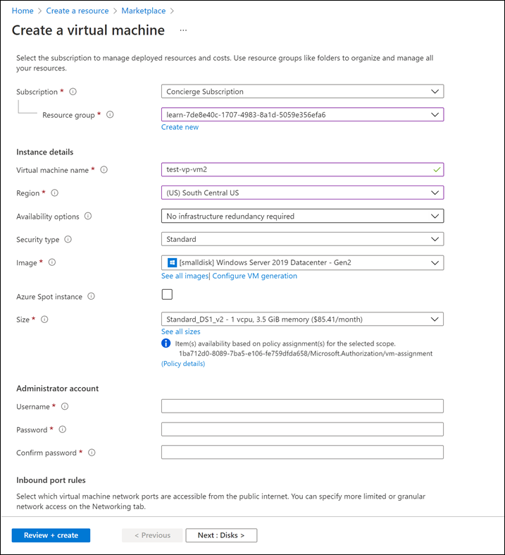

**Configure basic VM settings**

**Note**

As you add or change settings in the wizard, Azure validates each value and places a green check mark next to a validated field, or red error indicator below the field. You can hover over an error indicator to get more information about a validation issue.

**Note**

It's a best practice to use a standard naming convention for resource names so you can easily identify their purpose. Windows VM names are a bit limited - they must be between 1 and 15 characters, cannot contain non-ASCII or special characters, and must be unique in the current resource group.

On the **Basics** tab, enter the following values for each setting.

| **Setting** | **Value** |
| --- | --- |
| **Project details** |  |
| Subscription | Concierge Subscription (the subscription that should be billed for VM hours). |
| Resource Group | Select ***[sandbox resource group name]***. |
| **Instance details** |  |
| Virtual machine name | Enter a name for your VM, such as **test-vp-vm2** (for Test Video Processor VM #2). |
| Region | Select a region close to you from the global regions listed in the following table. |
| Availability options | Accept default **No infrastructure redundancy required**. This option is used to ensure the VM is highly available by grouping multiple VMs together to deal with planned or unplanned maintenance events or outages. |
| Security type | Standard |
| Image | Select **[smalldisk] Windows Server 2019 Datacenter - Gen1** from the dropdown list. |
| Azure Spot instance | Accept default (unchecked). |
| Size | The **Size** field is not directly editable. Select or accept the default **Standard DS1 v2**, which will give the VM 1 CPU and 3.5 GB of memory. Optionally, select the field to view recommended or recently chosen sizes; select **See all sizes** to explore filters for sizes based on vCPUs, RAM, Data disks, operations per second, and cost. Select the X in the top right of the pane to close the pane. |
| **Administrator account** |  |
| Username | Enter a username you will use to sign in to the VM. |
| Password | Enter a password that's at least 12 characters long and has at least three of the following four characteristics: one lower case character, one uppercase character, one number, and one special character that is not '\' or '-'. Use something you will remember or write it down, as you will need it later. |
| Confirm password | Confirm your password. |
| **Inbound port rules** |  |
| Public inbound ports | Select **Allow selected ports**. We want to be able to access the desktop for this Windows VM using RDP. |
| Select inbound ports | Select **RDP (3389)** from the dropdown list. As the note in the UI indicates, we can also adjust the network ports after we create the VM. |
| **Licensing** |  |
| Would you like to use an existing Windows Server License | Leave unchecked |
|  |  |

**Configure disks for the VM**

1. On the **Disks** tab, enter or select the following values for each setting.

| **Setting** | **Value** |
| --- | --- |
| **Disk options** |  |
| OS disk type | Accept the default **Premium SSD (locally redundant storage)**. |
| Encryption type | Accept the default **(Default) Encryption at-rest with a platform-managed key**. |
| Enable Ultra Disk compatibility | Accept default (unchecked) |
| **Data disks** |  |
| Select **Create and attach a new disk** link. The **Create a new disk** pane appears. | Accept all the default values for the following settings: *Name*; *Source type*; *Size*; *Encryption type*; and *Enable shared disk*. This is where you could use a snapshot, or Storage Blob, to create a VHD. |

1. Select **OK** to save the settings, and close the pane.

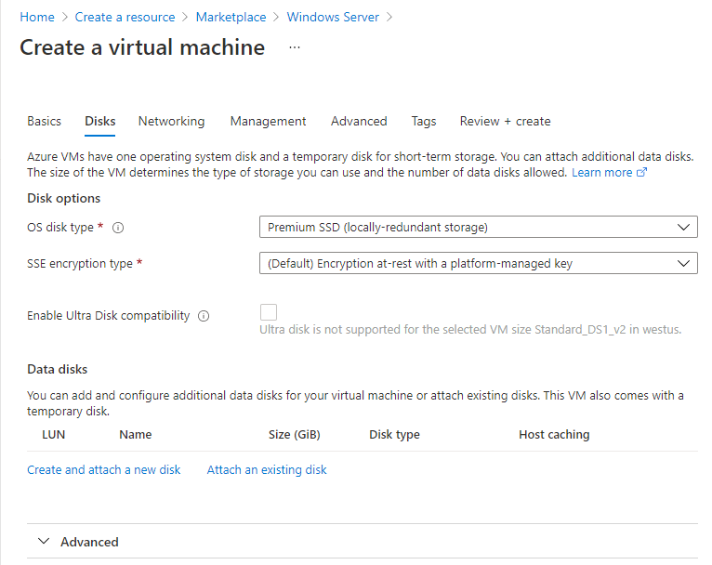

1. On the **Create a virtual machine** pane **Disks** tab, under **Data disks**, there should now be a new row showing the newly configured disk.

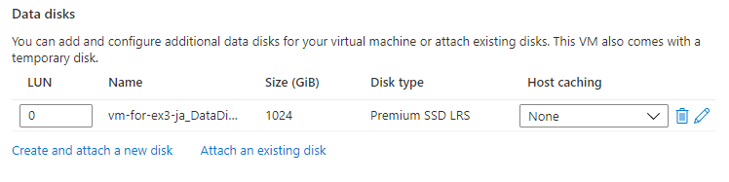

**Configure the network**

1. Select **Next : Networking**.

In a production system, where other components are already in use, it would be important to use an *existing* virtual network so that the VM can communicate with the other cloud services in the production solution. If no virtual network has defined in this location, create it here and configure the:

* + **Subnet**: First subnet to subdivide the address space - it must fit within the defined address space. After the VNet is created, you can add more subnets.
  + **Public IP**: Overall IPV4 space available to this network.

1. On the **Networking** tab, let's change some of the settings. Under the input field for **Virtual network**, select **Create new**. The **Create virtual network** pane appears.
2. On the **Create virtual network** pane, enter the following values for each setting.

| **Setting** | **Value** |
| --- | --- |
| **Address space** |  |
| *Address range* | Select the checkbox in the row below the heading, and enter 172.16.0.0/16 to give the address space a full range of addresses. If another address range row exists, select it to delete it. |
| **Subnets** |  |
| *Subnet name* | Select the checkbox in the row below the heading, and enter *default* in the first input field. If another row exists, select it to delete it. |
| *Address range* | In the empty input field, enter 172.16.1.0/24 to give the subnet 256 IP addresses of space. |

1. Select **OK** to save your settings and return to the **Create a virtual machine** pane.

**Note**

By default, Azure will create a virtual network, network interface, and public IP for your VM. It's not trivial to change networking options after the VM has been created so always double-check the network assignments for services you create in Azure.

**Finish configuring the VM and create the image**

On the **Create a virtual machine** pane, the rest of the tabs have reasonable defaults and there's no need to change any of them. You can explore the other tabs if you like. Each field has an (i) icon next to it which, if selected, will show a detailed definition of that configuration setting. Reviewing field descriptions is a great way to learn about the settings you can use to configure the VM.

1. Select **Review + create**. The system will validate your options and display details about the VM being created.
2. Select **Create** to deploy the VM. The Azure dashboard will show the name VM that's being deployed and details about your deployment. Deployment may take several minutes.
3. After deployment completes, select **Go to resource**. Your virtual machine pane appears.

Now, let's look at what we can do with this VM.